# 

**DEPARTMENT OF INFORMATION SCIENCE AND ENGINEERING**

**A MINI PROJECT REPORT ON**

**“PROJECT TITLE”**

*Submitted in the partial fulfillment of the requirements in the 3rd semester of*

**BACHELOR OF ENGINEERING**

**IN**

**INFORMATION SCIENCE AND ENGINEERING**

**FOR**

**COURSE NAME: MINI PROJECT**

**COURSE CODE: 20ISE391A**

By

**STUDENT NAME 1 - USN**

**STUDENT NAME 2 - USN**

***Under the guidance of***

**GUIDE NAME**

Designation



**CERTIFICATE**

Certified that the project work entitled “Auto-Attendance System Using Face Recognition” carried out by Mr. Ashwin N, bearing USN 1NH19IS020, a bonafide student of III semester in partial fulfillment for the award of Bachelor of Engineering in Information Science & Engineering of New Horizon College of Engineering, an autonomous institute affiliated to the Visvesvaraya Technological University, Belagavi during the year 2021-22. It is certified that all corrections / suggestions indicated for Internal Assessment have been incorporated. The project report has been approved as it satisfies the academic requirements in respect of Mini Project work prescribed for the said Degree.

**Name & Signature of Guide Name & Signature of HOD**

Mrs. Karthiyayini Dr. Anandhi R J

**Examiners :**

**Name Signature**

1. …………………………………………………. ………………………………..
2. …………………………………………………… …………………………………

**ACKNOWLEDGEMENT**

Any project is a task of great enormity and it cannot be accomplished by an individual without support and guidance. I am grateful to a number of individuals whose professional guidance and encouragement has made this project completion a reality.

We have a great pleasure in expressing our deep sense of gratitude to the beloved Chairman **Dr. Mohan Manghnani** for having provided us with a great infrastructure and well-furnished labs.

We take this opportunity to express our profound gratitude to the Principal **Dr.Manjunatha** for his constant support and management.

We are grateful to **Dr. R J Anandhi** , Professor and Head of Department of ISE, New Horizon College of Engineering, Bengaluru for her strong enforcement on perfection and quality during the course of our mini project work.

We would like to express our thanks to the guide **Mr. Gangadhar Immadi**, Senior Assistant Professor, Department of ISE, New Horizon College of Engineering, Bengaluru who has always guided us in detailed technical aspects throughout our mini project.

We would like to mention special thanks to all the Teaching and Non-Teaching staff members of Information Science and Engineering Department, New Horizon College of Engineering, Bengaluru for their invaluable support and guidance.

**Student Name USN**

**Student Name USN**

**TABLE OF CONTENTS**

**CHAPTER 1 1**

Introduction 1

1.1 Motivation of the Project

1.2 Problem Statement

**CHAPTER 2 4**

Literature Survey

2.1 Existing System

2.2 Proposed System

2.3 Objectives of the Proposed System

**CHAPTER 3 8**

System Requirement Specifications

3.1 Hardware Requirements

3.2 Software Requirements

**CHAPTER 4 12**

System Design

4.1 Architectural Design 12

4.2 Algorithm/Flowchart

**CHAPTER 5 18**

Implementation

5.1 System Modules

**CHAPTER 6 38**

Results

**CHAPTER 7 39**

Conclusion & Future Enhancement 39

**REFERENCES**

**LIST OF TABLES**

|  |  |  |
| --- | --- | --- |
| **Table No.** | **Table Name** | **Page No.** |

**LIST OF FIGURES**

|  |  |  |
| --- | --- | --- |
| **Figure No.** | **Figure Name** | **Page No.** |

**Abstract**

Minimum 150- 200 words

# CHAPTER 1

# **INTRODUCTION**

## 1.1 Introduction

## 1.2 Motivation of the project

## 1.3 Problem Definition

# CHAPTER 2

# **LITERATURE SURVEY**

### 2.1 Existing System

# CHAPTER 3

# **SYSTEM REQUIREMENTS SPECIFICATION**

### 3.1 Hardware Requirements

The following are needed to efficiently use the application.

Processor - Intel Core i3 and above

Speed - 2.5 GHz

RAM - 8 GB (min)

Hard Disk - 50 GB (min)

### 3.2 Software Requirements

Software requirements define software resource fundamentals that need to be installed on a workstation to provide optimum working of a software. The following are required for optimal development and usage of the application.

Operating System - Windows 7 and above

Programming Language - Python 3.7

Compiler - Visual Studio, IDLE, Anaconda, Spyder

# CHAPTER 4

# **SYSTEM DESIGN**

## 4.1 System Architecture

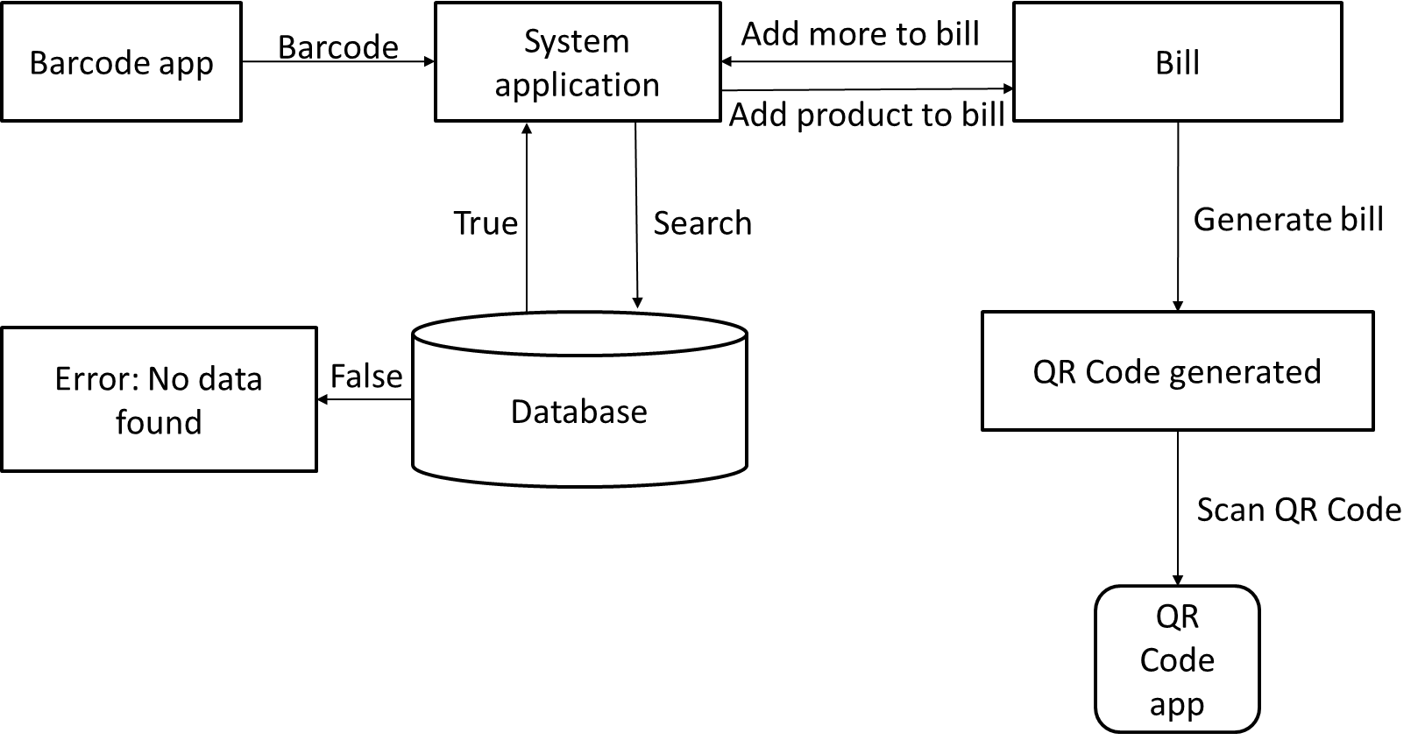

Fig 4.1: System architecture

## 4.2 Flowchart of Proposed System

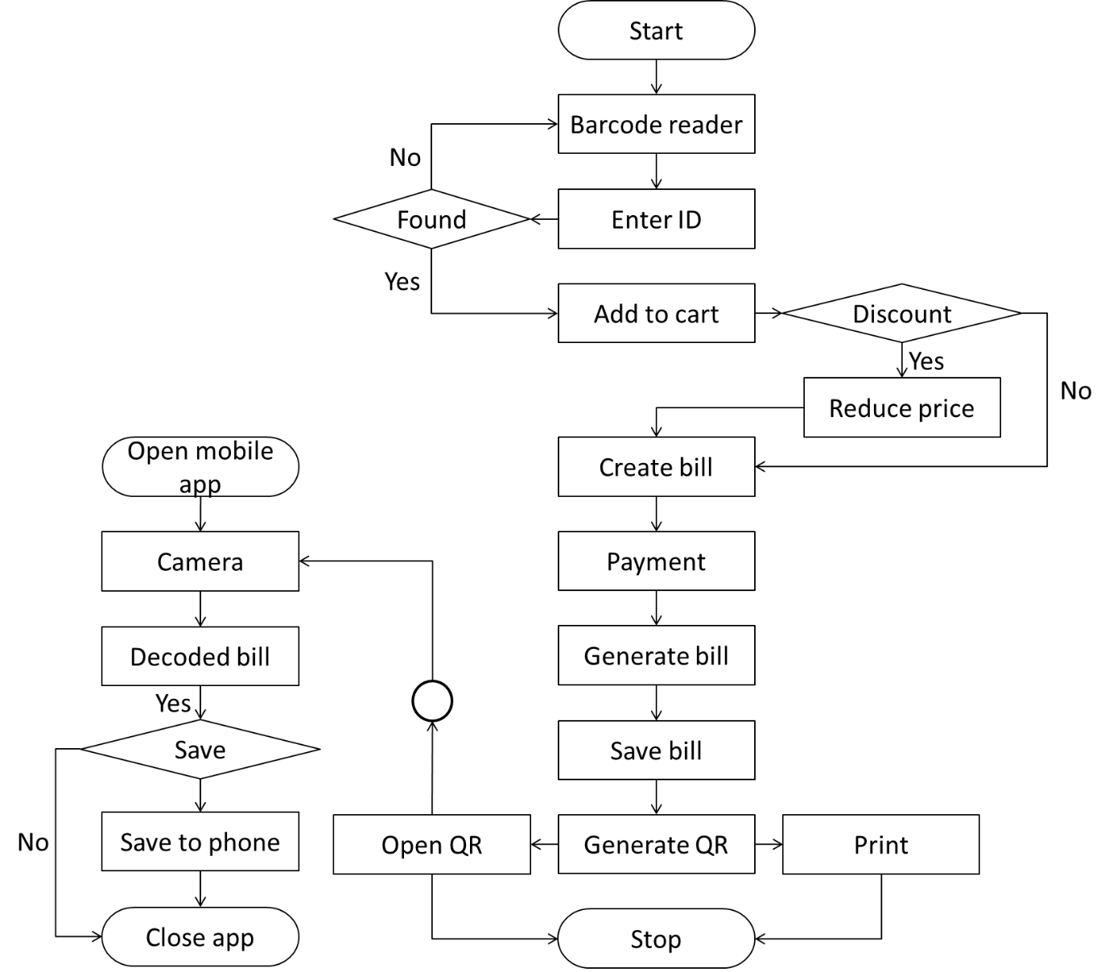

Fig 4.2: Flowchart of proposed system

# CHAPTER 5

# **IMPLEMENTATION**

## 5.1 Code Implementation

## CHAPTER 6

# **EXPERIMENTAL RESULTS**

## 6.1 Outcome of Proposed System

6.1.1 Select a particular latitude and longitude:

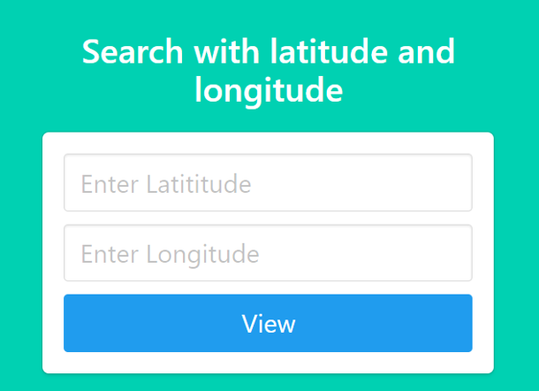

Fig 6.1: Selecting a particular latitude and longitude

Slices the original data present in the excel sheet and takes into consideration of only those cases(crimes) which occurred at a particular latitude and longitude that is specified by the user in the options page.

Once the View button is clicked the sliced data is shown to the user in the form of a table in the next(details) page.

# 

Fig 6.2: Sliced data

6.1.2 Enter a time limit and a particular crime:

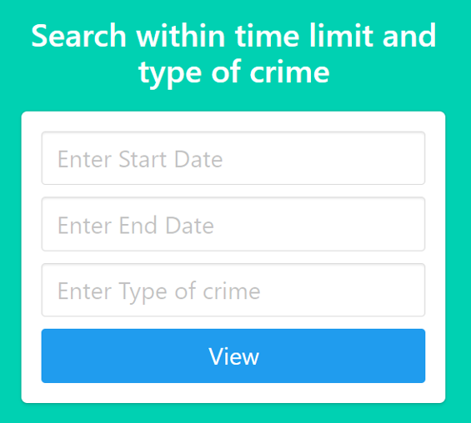

Fig 6.3: Entering time limit and crime type

Slices the original data present in the excel sheet and takes into consideration of only those cases(crimes) which happened/took place within the specified time range and belongs to a particular type of crime which are specified by the user in the options page.

This data is then organised by a clustering algorithm, which returns us a plot where x is longitude and y is latitude and forms three clusters based on the density of crimes which took place in a particular region. Each cluster has a unique colour.

Once the View button is clicked a window pop’s up and shows a plot which resembles the image shown below.

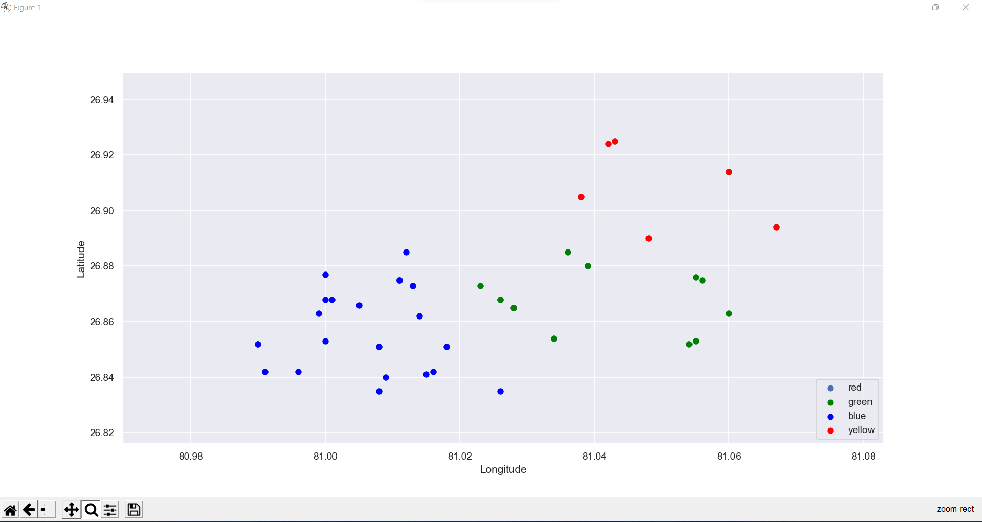

Fig 6.4: Clusters formed

# CHAPTER 7

# **CONCLUSION AND FUTURE ENHANCEMENT**

## 7.1 Conclusion

This project was about improving the existing billing system by making it digitalized. A better way of billing system was implemented.

## 7.2 Future Enhancement

This application has much potential for future enhancement.

# **REFERENCES**

1 Research Papers

2 Web link

3 Books